

***Assignment of CSE 4128***

***Khulna University of Engineering & Technology***

***Computer Science and Engineering***

**Name :** Doniel Tripura

**Roll :** 1907121 (section B2)

**Assignment No :** 02

**Assignment Topic**: Implementing Canny Edge Detection Algorithm



Date: 06 March, 2024

**Introduction:** The objective of this assignment is to implement the Canny edge detection algorithm, a popular technique for detecting edges in images. This algorithm involves several key steps, including

* The application of differential operators along the x and y axes,
* Non-maximum suppression to identify peaks in the gradient magnitude, and
* Hysteresis thresholding to locate edge strings in the image.

After completing this assignment, we gained hands-on experience in image processing techniques and deepened our understanding of edge detection algorithms.

**Objective:** The goal of this assignment is to implement the Canny edge detection algorithm using Python and relevant libraries such as NumPy and OpenCV. We learned to apply differential operators, perform non-maximum suppression, and apply hysteresis thresholding to detect edges in images.

**Assignment Steps:**

1. **Differential Operators:**
   * We have written Python functions to compute the image gradients along the x and y axes using differential operators (e.g., Sobel or Prewitt).
   * We took the value of sigma as input from the user for Gaussian smoothing.
2. **Non-maximum Suppression:**
   * We implemented the non-maximum suppression algorithm to identify peaks in the gradient magnitude.
3. **Hysteresis Thresholding:**
   * We implemented hysteresis thresholding to locate edge strings in the image.
   * Then defined high and low threshold values (upper and lower bounds).
   * Pixels with gradient magnitudes above the high threshold are strong edges.
   * Pixels connected to strong edges and above the low threshold are weak edges.
   * Then we applied hysteresis thresholding to the results obtained in step 2.
   * Visualize the final edge detection results.

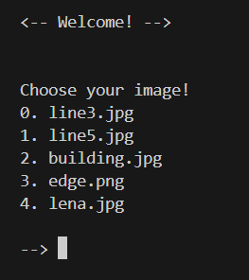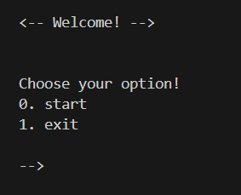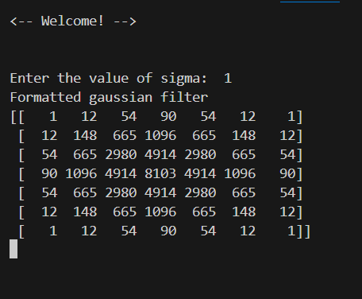**Conclusion:** By completing this assignment, you will gain practical experience in implementing the Canny edge detection algorithm and enhance your understanding of image processing concepts. This knowledge is valuable in fields such as computer vision, robotics, and medical imaging, where edge detection plays a crucial role in object detection and recognition.

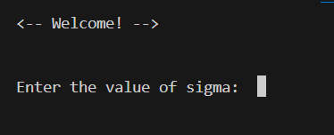**User Interface:**

**Results:**





